void main (){

String ? profession;

print(profession);

}

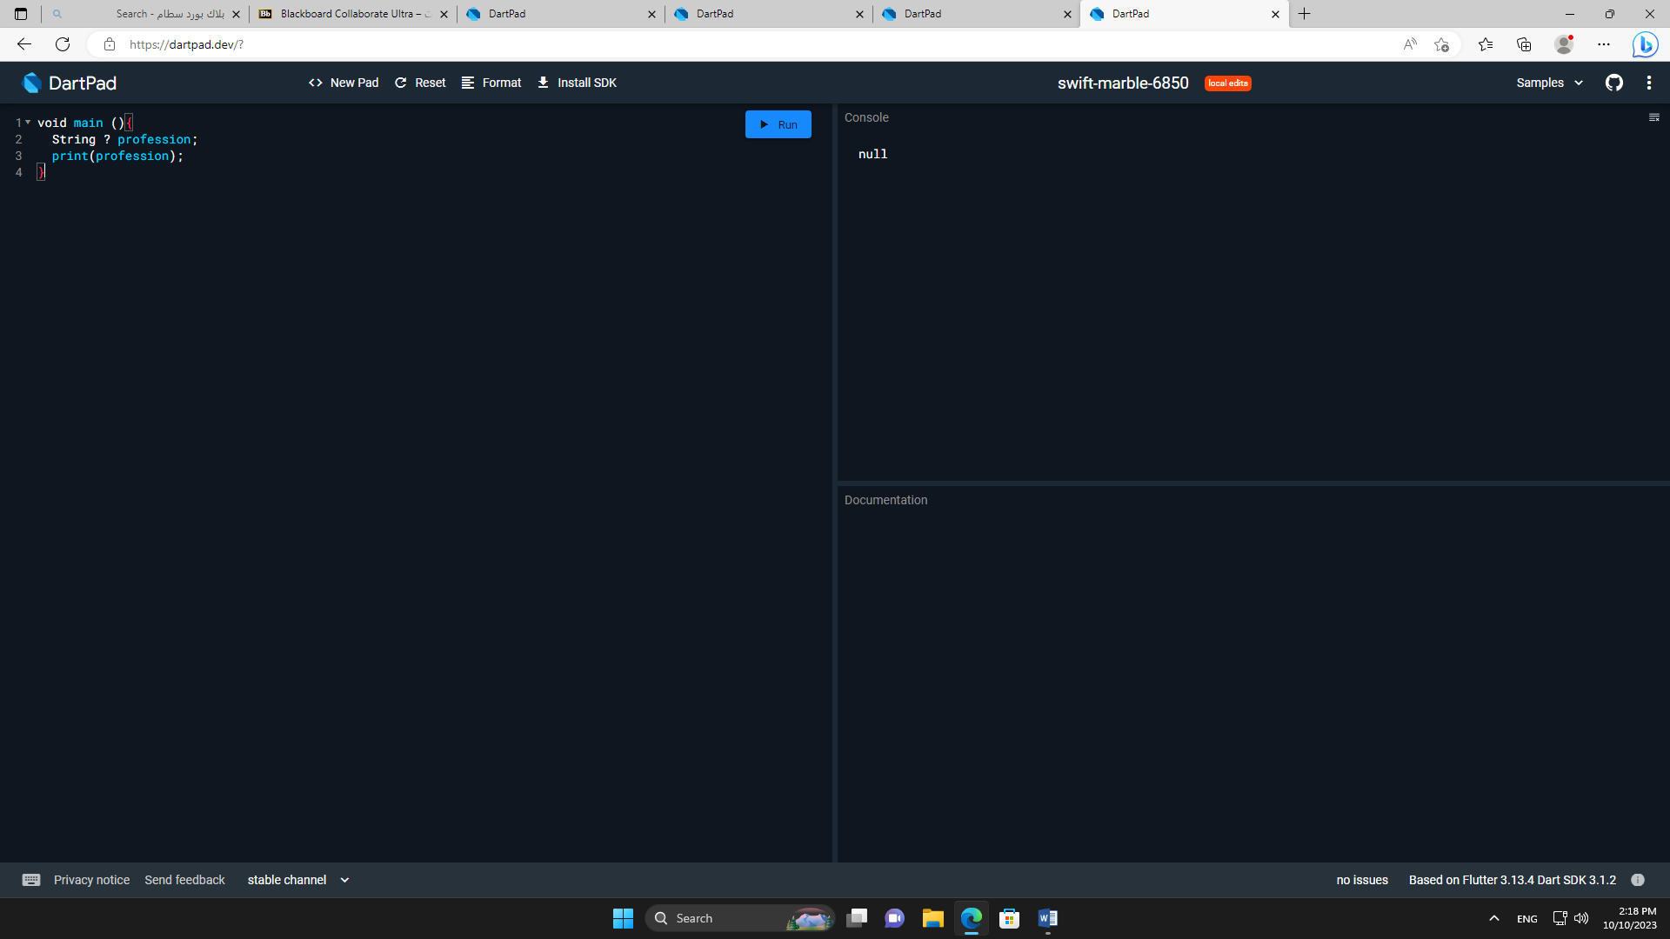

void main (){

String ? profession=

'basketball player' ;

print(profession);

}

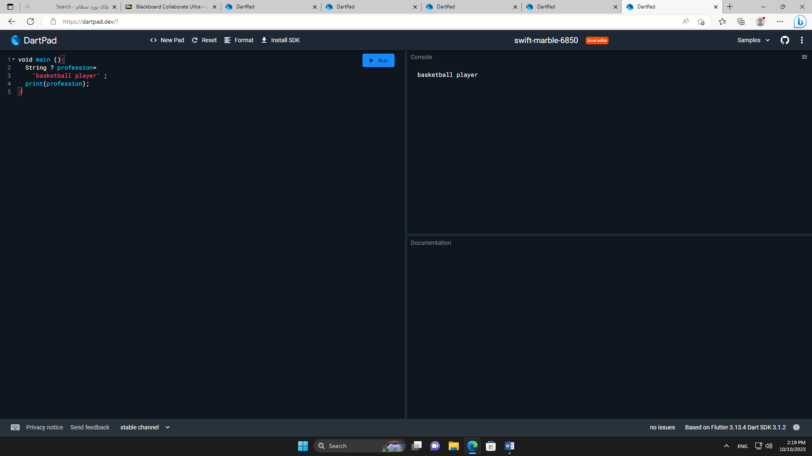

class Name {

String givenName;

String?surname ;

bool surnameIsFirst;

Name (this.givenName,this.surname,this.surnameIsFirst);

@override

String toString(){

if(surname!=null){

if(surnameIsFirst){

return '$surname $givenName';

}else {

return ' $givenName $surname';

}

}else {

return givenName ;

}

}

}

void main (){

Name name1= Name('sara','saleh',true);

print(name1);

Name name2= Name('dana',null,false);

print(name2);

}

